Primary Source Analysis: Buddhism
DIRECTIONS: Using Google, find the basic definitions of Buddhism. Then read and analyze the selection from the Buddha’s First Sermon and answer the questions below. Be sure to answer the questions in complete sentences.
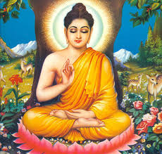
Buddhism

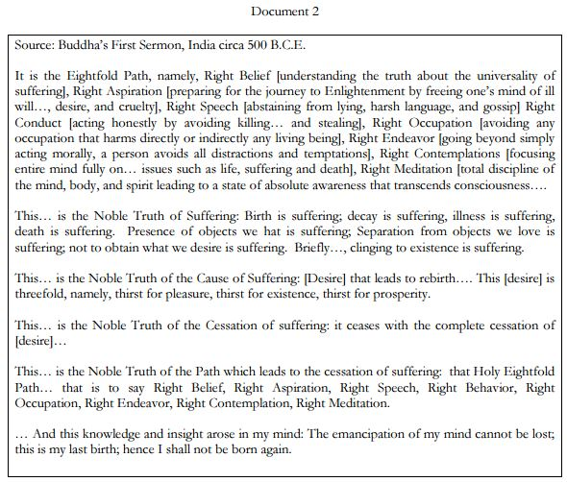
1. What information does the Buddha’s First Sermon provide about the Eightfold Path and the Four Noble Truths?

2. How does Buddhism compare to Hinduism?

