Primary Source Analysis: Hinduism
DIRECTIONS: Using Google, find the basic definitions of Hinduism and Bhagavad Gita. Then read and analyze the selection from the Bhagavad Gita and answer the questions below. Be sure to answer the questions in complete sentences.
Hinduism

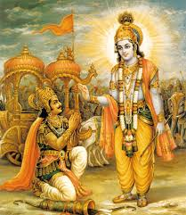
Bhagavad Gita

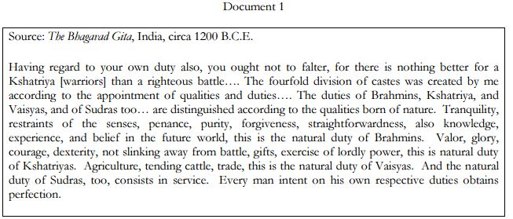
1. What was the impact of Hinduism on the social structure of India during the Classical period?

2. What information does the Bhagavad Gita provide about the caste system?

