DIRECTIONS: Use Google to identify the important details, achievements, and annotations about each historical figure from the ages of the Renaissance, Reformation or Exploration listed below. Remember- avoid using Wikipedia!

Historical Figure | Annotations
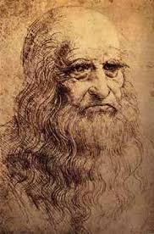Leonardo da Vinci  Nation: _______________________ | Time Period: ______________________________________  Achievements: ____________________________________________________________________________ ______________________________________________________________________________________________ ______________________________________________________________________________________________ ______________________________________________________________________________________________  Notes: ______________________________________________________________________________________  ______________________________________________________________________________________________  ______________________________________________________________________________________________
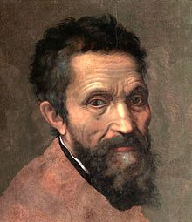  Michelangelo  Nation: _______________________ | Time Period: ______________________________________  Achievements: ____________________________________________________________________________ ______________________________________________________________________________________________ ______________________________________________________________________________________________ ______________________________________________________________________________________________  Notes: ______________________________________________________________________________________  ______________________________________________________________________________________________  ______________________________________________________________________________________________
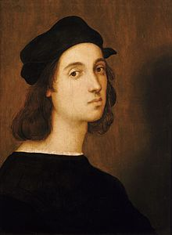  Raphael  Nation: _______________________ | Time Period: ______________________________________  Achievements: ____________________________________________________________________________ ______________________________________________________________________________________________ ______________________________________________________________________________________________ ______________________________________________________________________________________________  Notes: ______________________________________________________________________________________  ______________________________________________________________________________________________  ______________________________________________________________________________________________
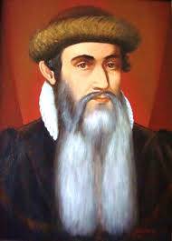  Johann Gutenberg  Nation: _______________________ | Time Period: ______________________________________  Achievements: ____________________________________________________________________________ ______________________________________________________________________________________________ ______________________________________________________________________________________________ ______________________________________________________________________________________________  Notes: ______________________________________________________________________________________  ______________________________________________________________________________________________  ______________________________________________________________________________________________
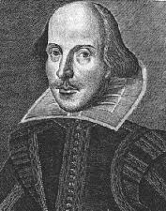  William Shakespeare  Nation: _______________________ | Time Period: ______________________________________  Achievements: ____________________________________________________________________________ ______________________________________________________________________________________________ ______________________________________________________________________________________________ ______________________________________________________________________________________________  Notes: ______________________________________________________________________________________  ______________________________________________________________________________________________  ______________________________________________________________________________________________
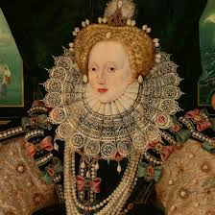  Elizabeth I  Nation: _______________________ | Time Period: ______________________________________  Achievements: ____________________________________________________________________________ ______________________________________________________________________________________________ ______________________________________________________________________________________________ ______________________________________________________________________________________________  Notes: ______________________________________________________________________________________  ______________________________________________________________________________________________  ______________________________________________________________________________________________
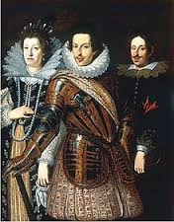  Medici Family  Nation: _______________________ | Time Period: ______________________________________  Achievements: ____________________________________________________________________________ ______________________________________________________________________________________________ ______________________________________________________________________________________________ ______________________________________________________________________________________________  Notes: ______________________________________________________________________________________  ______________________________________________________________________________________________  ______________________________________________________________________________________________
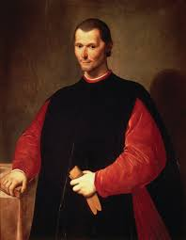  Machiavelli  Nation: _______________________ | Time Period: ______________________________________  Achievements: ____________________________________________________________________________ ______________________________________________________________________________________________ ______________________________________________________________________________________________ ______________________________________________________________________________________________  Notes: ______________________________________________________________________________________  ______________________________________________________________________________________________  ______________________________________________________________________________________________
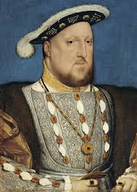  Henry VIII  Nation: _______________________ | Time Period: ______________________________________  Achievements: ____________________________________________________________________________ ______________________________________________________________________________________________ ______________________________________________________________________________________________ ______________________________________________________________________________________________  Notes: ______________________________________________________________________________________  ______________________________________________________________________________________________  ______________________________________________________________________________________________
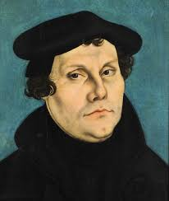  Martin Luther  Nation: _______________________ | Time Period: ______________________________________  Achievements: ____________________________________________________________________________ ______________________________________________________________________________________________ ______________________________________________________________________________________________ ______________________________________________________________________________________________  Notes: ______________________________________________________________________________________  ______________________________________________________________________________________________  ______________________________________________________________________________________________
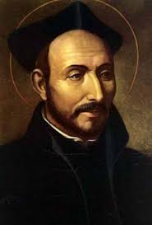  Ignatius de Loyola  Nation: _______________________ | Time Period: ______________________________________  Achievements: ____________________________________________________________________________ ______________________________________________________________________________________________ ______________________________________________________________________________________________ ______________________________________________________________________________________________  Notes: ______________________________________________________________________________________  ______________________________________________________________________________________________  ______________________________________________________________________________________________
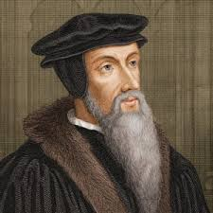  John Calvin  Nation: _______________________ | Time Period: ______________________________________  Achievements: ____________________________________________________________________________ ______________________________________________________________________________________________ ______________________________________________________________________________________________ ______________________________________________________________________________________________  Notes: ______________________________________________________________________________________  ______________________________________________________________________________________________  ______________________________________________________________________________________________
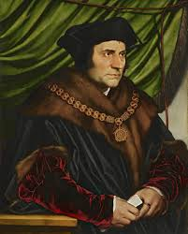  Sir Thomas More  Nation: _______________________ | Time Period: ______________________________________  Achievements: ____________________________________________________________________________ ______________________________________________________________________________________________ ______________________________________________________________________________________________ ______________________________________________________________________________________________  Notes: ______________________________________________________________________________________  ______________________________________________________________________________________________  ______________________________________________________________________________________________
Jesuits  Nation: _______________________ | Time Period: ______________________________________  Achievements: ____________________________________________________________________________ ______________________________________________________________________________________________ ______________________________________________________________________________________________ ______________________________________________________________________________________________  Notes: ______________________________________________________________________________________  ______________________________________________________________________________________________  ______________________________________________________________________________________________
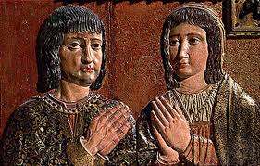  Isabella & Ferdinand  Nation: _______________________ | Time Period: ______________________________________  Achievements: ____________________________________________________________________________ ______________________________________________________________________________________________ ______________________________________________________________________________________________ ______________________________________________________________________________________________  Notes: ______________________________________________________________________________________  ______________________________________________________________________________________________  ______________________________________________________________________________________________
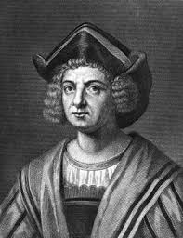  Christopher Columbus  Nation: _______________________ | Time Period: ______________________________________  Achievements: ____________________________________________________________________________ ______________________________________________________________________________________________ ______________________________________________________________________________________________ ______________________________________________________________________________________________  Notes: ______________________________________________________________________________________  ______________________________________________________________________________________________  ______________________________________________________________________________________________
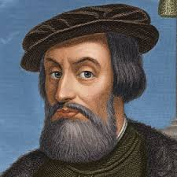  Hernan Cortez  Nation: _______________________ | Time Period: ______________________________________  Achievements: ____________________________________________________________________________ ______________________________________________________________________________________________ ______________________________________________________________________________________________ ______________________________________________________________________________________________  Notes: ______________________________________________________________________________________  ______________________________________________________________________________________________  ______________________________________________________________________________________________
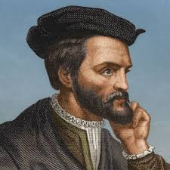  Jacques Cartier  Nation: _______________________ | Time Period: ______________________________________  Achievements: ____________________________________________________________________________ ______________________________________________________________________________________________ ______________________________________________________________________________________________ ______________________________________________________________________________________________  Notes: ______________________________________________________________________________________  ______________________________________________________________________________________________  ______________________________________________________________________________________________
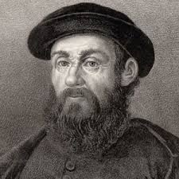  Ferdinand Magellan:  Nation: _______________________ | Time Period: ______________________________________  Achievements: ____________________________________________________________________________ ______________________________________________________________________________________________ ______________________________________________________________________________________________ ______________________________________________________________________________________________  Notes: ______________________________________________________________________________________  ______________________________________________________________________________________________  ______________________________________________________________________________________________
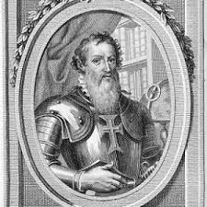  Prince Henry the Navigator  Nation: _______________________ | Time Period: ______________________________________  Achievements: ____________________________________________________________________________ ______________________________________________________________________________________________ ______________________________________________________________________________________________ ______________________________________________________________________________________________  Notes: ______________________________________________________________________________________  ______________________________________________________________________________________________  ______________________________________________________________________________________________
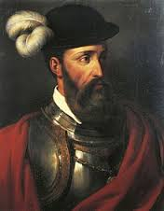  Francisco Pizzarro  Nation: _______________________ | Time Period: ______________________________________  Achievements: ____________________________________________________________________________ ______________________________________________________________________________________________ ______________________________________________________________________________________________ ______________________________________________________________________________________________  Notes: ______________________________________________________________________________________  ______________________________________________________________________________________________  ______________________________________________________________________________________________
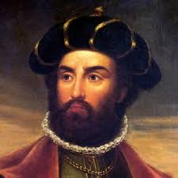  Vasco de Gama  Nation: _______________________ | Time Period: ______________________________________  Achievements: ____________________________________________________________________________ ______________________________________________________________________________________________ ______________________________________________________________________________________________ ______________________________________________________________________________________________  Notes: ______________________________________________________________________________________  ______________________________________________________________________________________________  ______________________________________________________________________________________________
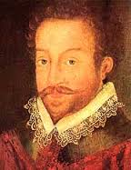  Sir Francis Drake  Nation: _______________________ | Time Period: ______________________________________  Achievements: ____________________________________________________________________________ ______________________________________________________________________________________________ ______________________________________________________________________________________________ ______________________________________________________________________________________________  Notes: ______________________________________________________________________________________  ______________________________________________________________________________________________  ______________________________________________________________________________________________
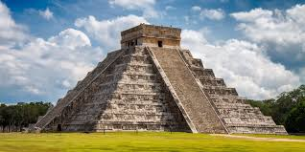  Mayans  Location: _____________________ | Time Period: ______________________________________  Achievements: ____________________________________________________________________________ ______________________________________________________________________________________________ ______________________________________________________________________________________________ ______________________________________________________________________________________________  Notes: ______________________________________________________________________________________  ______________________________________________________________________________________________  ______________________________________________________________________________________________
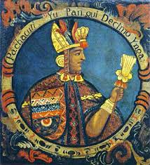  Incas  Location: _____________________ | Time Period: ______________________________________  Achievements: ____________________________________________________________________________ ______________________________________________________________________________________________ ______________________________________________________________________________________________ ______________________________________________________________________________________________  Notes: ______________________________________________________________________________________  ______________________________________________________________________________________________  ______________________________________________________________________________________________
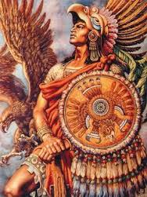  Aztecs  Location: _____________________ | Time Period: ______________________________________  Achievements: ____________________________________________________________________________ ______________________________________________________________________________________________ ______________________________________________________________________________________________ ______________________________________________________________________________________________  Notes: ______________________________________________________________________________________  ______________________________________________________________________________________________  ______________________________________________________________________________________________

