Annotations: River Valley Civilizations
DIRECTIONS: Using the link on heymissaworld.weebly.com, find the picture that matches the civilization and write down annotations (short, informative notes) for each of the categories. For annotations, more is not necessarily better- you will want to focus on the big ideas and add one or two supporting details.
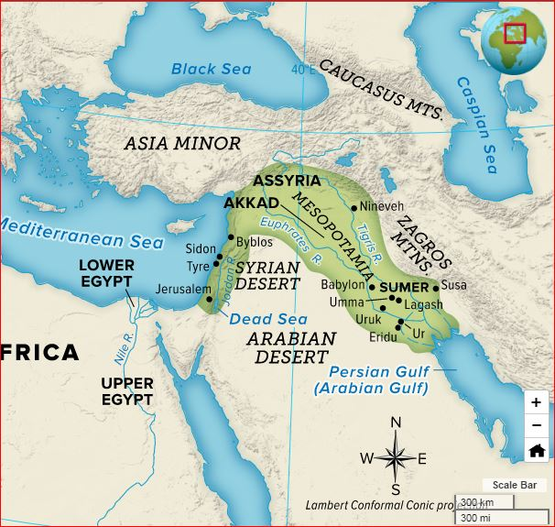
I. Mesopotamia
Location: _______________________________________________________________

Government & Administration: ______________________________________
___________________________________________________________________________
___________________________________________________________________________
___________________________________________________________________________

Religion: ________________________________________________________________
___________________________________________________________________________ ___________________________________________________________________________

Urban Centers:_________________________________________________________________________________________________ ____________________________________________________________________________________________________________________________________________________________________________________________________________________________________

Social Hierarchy: ______________________________________________________________________________________________ __________________________________________________________________________________________________________________ __________________________________________________________________________________________________________________

Contributions:_________________________________________________________________________________________________ __________________________________________________________________________________________________________________ __________________________________________________________________________________________________________________

II. Nile River Valley
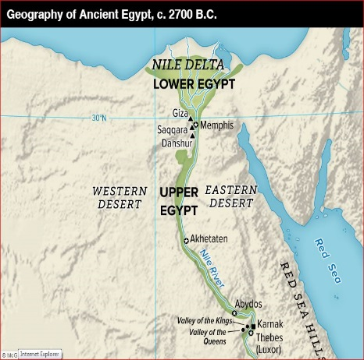
Location: _______________________________________________________________

Government & Administration: ______________________________________
___________________________________________________________________________
___________________________________________________________________________
___________________________________________________________________________

Religion: ________________________________________________________________
___________________________________________________________________________ ___________________________________________________________________________

Urban Centers:_________________________________________________________________________________________________ ____________________________________________________________________________________________________________________________________________________________________________________________________________________________________

Social Hierarchy: ______________________________________________________________________________________________ __________________________________________________________________________________________________________________ __________________________________________________________________________________________________________________

Contributions:_________________________________________________________________________________________________ __________________________________________________________________________________________________________________ __________________________________________________________________________________________________________________

III. Indus River Valley
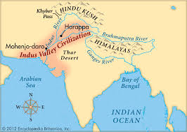
Location: _______________________________________________________________

Government & Administration: ______________________________________
___________________________________________________________________________
___________________________________________________________________________
___________________________________________________________________________

Religion: ________________________________________________________________
___________________________________________________________________________ ___________________________________________________________________________

Urban Centers:_________________________________________________________________________________________________ ____________________________________________________________________________________________________________________________________________________________________________________________________________________________________

Social Hierarchy: ______________________________________________________________________________________________ __________________________________________________________________________________________________________________ __________________________________________________________________________________________________________________

Contributions:_________________________________________________________________________________________________ __________________________________________________________________________________________________________________ __________________________________________________________________________________________________________________

IV. Huang He (Yellow) River Valley
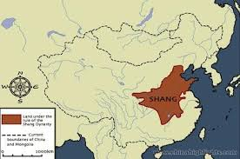
Location: _______________________________________________________________

Government & Administration: ______________________________________
___________________________________________________________________________
___________________________________________________________________________
___________________________________________________________________________

Religion: ________________________________________________________________
___________________________________________________________________________ ___________________________________________________________________________

Urban Centers:_________________________________________________________________________________________________ ____________________________________________________________________________________________________________________________________________________________________________________________________________________________________

Social Hierarchy: ______________________________________________________________________________________________ __________________________________________________________________________________________________________________ __________________________________________________________________________________________________________________

Contributions:_________________________________________________________________________________________________ __________________________________________________________________________________________________________________ __________________________________________________________________________________________________________________

V. Review

1. In your opinion, which river valley civilization contributed the most to human development?

2. How did location play a role in the success of these civilizations?

3. What factors helped these civilizations flourish and survive?

4. What are some of the contributions made by these ancient civilizations that are still used in the present day?

