Mapping Lab #1: Ancient River Valley Civilizations
DIRECTIONS: Using your Map Guidelines in your ISN, please locate, NEATLY label, and lightly shade (with COLORED PENCILS) the following items. Be sure to include all requirements that must be present on all maps. Read and follow ALL instructions carefully!
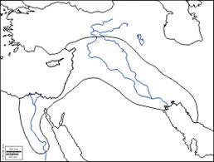
Ancient River Valley Civilizations:
Mesopotamia (_________-_________)
1. Draw & Label the following physical features:
- Zagros Mountains
- Caucasus Mountains
- Syrian Desert
2. Label & Shade the following bodies of water:
- Mediterranean Sea
- Tigris River
- Euphrates River
- Persian Gulf
3. Label the following regions & cities:
- Sumer - Babylon
- Assyria - Jerusalem
- Akkad - Uruk
- Ur - Umma
4. Label, Outline, and Shade the Fertile Crescent.

Ancient River Valley Civilizations:
Nile River Valley (_________-_________)
1. Draw & Label the following physical features:
- Egypt
- Nile Delta
- Western Desert
- Eastern Desert
- Tropic of Cancer
2. Label & Shade the following bodies of water:
- Mediterranean Sea
- Nile River
- Red Sea
3. Label the following regions & cities:
- Thebes - Karnak
- Memphis - Valley of the Kings
- Saqqara - Valley of the Queens
- Giza

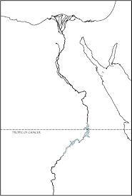

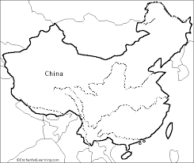
Ancient River Valley Civilizations:
Huang He River Valley
(_________-_________)
1. Draw & Label the following physical features:
- Gobi Desert
- Himalayas Mountains
2. Label & Shade the following bodies of water:
- Huang He (Yellow) River
- Yellow Sea
- East China Sea
3. Label the following regions & cities:
- China
- Mongolia
- Taiwan
4. Label & Shade the Following:
- Huang He River Valley

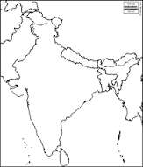
Ancient River Valley Civilizations:
Indus River Valley (_________-_________)
1. Draw & Label the following physical features:
- Hindu Kush
- Himalayas Mountains
- Thar Desert
2. Label the following bodies of water:
- Indian Ocean
- Bay of Bengal
- Indus River
- Ganges River
- Arabian Sea
3. Label the following regions & cities:
- Mohenjo-Daro
- Harappa
4. Label & Shade the following:
- Indus River Valley

