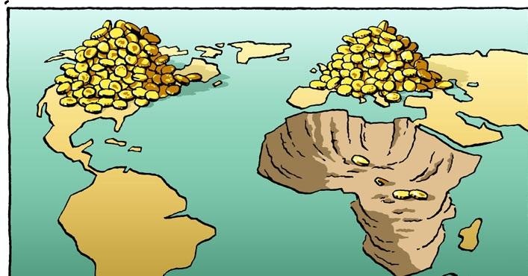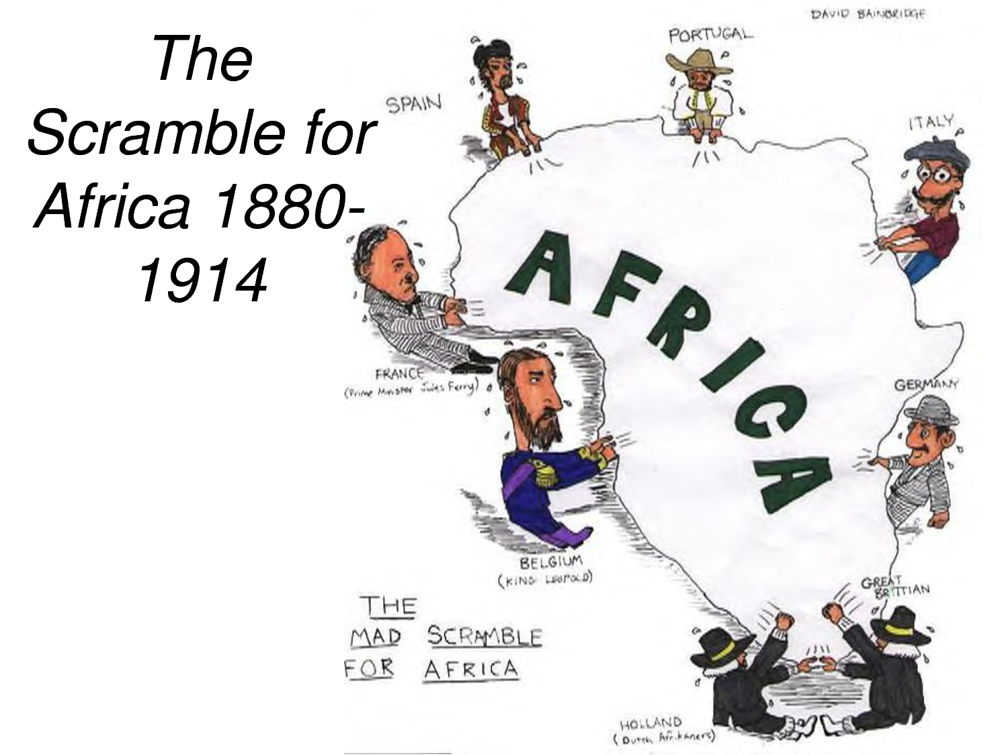
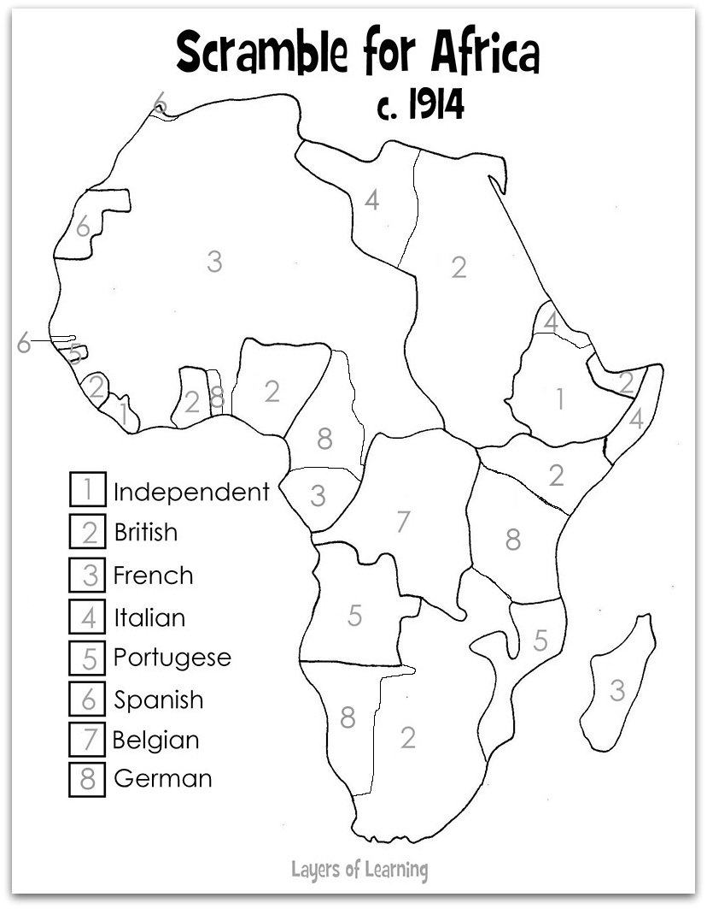

The Scramble for Africa
A. Background
1. Africa first peaked European and American interests during the slave trade in the 1700’s.
2. Not much (if anything) was known about interior Africa.
3. As European territories became ‘set’, Kings and Queens wanted to expand their control.
4. Africa was the obvious choice, as it was near and held many natural resources.
~Europeans did not consider Native Africans as equals, so they saw no problem in taking over their territory
B. Early Colonial Rule
1. In 1884 the major European Powers met to discuss how they would divide Africa.
2. This became known as the Berlin Conference of 1884.
~ African Natives were not invited to the conference
3. The major powers, Britain, France, Portugal, Italy, Belgium, and Germany divided the territory to best serve their needs.
~These European Boundaries often crossed social and cultural boundaries, leading to internal conflict
4. As internal conflicts increased amongst native groups, the European powers were able to increase their control and power, taking advantage of weaknesses.
5. By 1895, all of Africa was controlled by European leaders, except Liberia.
6. Liberia had been purchased by the United States during the Berlin Conference.
~Once slaves were freed in the United States, they had the option to move back
to Liberia and be given land to live off
C. End of Colonial Rule
1. Colonial Rule in Africa is short lived.
2. By 1950- almost all areas were actively seeking independence from European Powers.
~Some peacefully, others through war
3. The Independence movement brought to light many existing problems in Africa.
~Economies were built around European needs- Not African
~Borders were in dispute (Traditional vs European)
~Civil Wars amongst Natives over who would gain control
~Genocides occurred due to differences in religions, languages, and ideologies
4. 1960 became known as the ‘Year of Independence’, as most countries were granted their freedom.
~Once a few European powers left, economies and safety went down
5. Today, Sudan, Nigeria, Ethiopia, and Somalia are still fighting battles due to territory disputes created by Colonial rule.
6. The legacy of the colonial rule on Africa has a strong presence.
~Common languages are French and English (due to colonial rule)
~Many names and places have European names
7. Economies of Africa, the United States, and European nations are strongly linked, as Africa is a main exporter of Uranium, Gold, Coal, and Diamonds, which are sold mostly to their old colonial empires, because they have close ties to these countries.

Name_____________________________________Period_____________Date________

The Scramble for Africa
A. Background
1. Africa first peaked _______________ and ____________ interests during the slave trade in the 1700’s.
2. Not much (if anything) was known about _________________ Africa.
3. As ____________ territories became ‘set’, Kings and Queens wanted to ______________their control.
4. Africa was the obvious choice, as it was ________and held many ________________________
~Europeans did ____________consider Native Africans as____________, so they saw ______________________in taking over their territory
B. Early Colonial Rule
1. In 1884 the major European Powers met to discuss how they would __________________
2. This became known as the______________________________________.
~ African Natives were __________________to the conference
3. The major powers, ____________, ___________, _____________, __________, ___________, and ________________divided the territory to best serve their needs.
~These European Boundaries often crossed __________________and ___________________ boundaries, leading to internal conflict
4. As _____________conflicts increased amongst native groups, the European powers were able to _______________their _____________and power, taking advantage of_________________________.
5. By____________, all of Africa was controlled by European leaders, except _____________.
6. Liberia had been _________________by the _______________________during the Berlin Conference.
~Once slaves were __________in the United States, they had the _____________to move back
to _______________and be given _____________to live off
C. End of Colonial Rule
1. Colonial Rule in Africa is_______________________.
2. By 1950- almost all areas were actively seeking _______________________from European Powers.
~Some _________________, others through ___________________
3. The Independence movement brought to light many _____________________________in Africa.
~_____________________ were built around ______________________ Not African
~Borders were in __________________(Traditional vs European)
~______________________________ amongst Natives over who would gain control
~_______________ occurred due to differences in________________, __________________ , and ____________________
4. ___________________became known as the ‘_____________________________________’, as most countries were granted their freedom.
~Once a few European powers left, ______________________and _______________went down
5. Today, Sudan, ___________________, Ethiopia, and __________________are still fighting battles due to territory disputes created by_____________________________.
6. The legacy of the colonial rule on Africa has a_________________________.
~________________________ are French and English (due to colonial rule)
~Many names and places have ___________________________
7. Economies of_______________, the_____________________, and _______________________ nations are__________________________, as Africa is a main exporter of Uranium, ________________, Coal, and________________________, which are sold mostly to their old colonial empires, because they have ______________________________to these countries.

