Directions: The first thing you need to do is use a device and Google your term plus the word ‘definition’. Then, you will need to write a complete sentence that uses the word correctly! Enjoy your learning and this is due at the END OF THE TIMED PERIOD!
Vocabulary Term: | Definition: | Sentence Use:
Assembly Line
(a-sem-blee line)
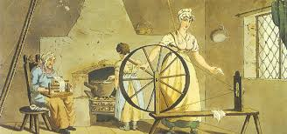
Cottage Industry
(cot-ta-ge in-dus-try)
Collective Bargaining
(col-lec-tive bar-gain-ing)
Corporation
(cor-por-a-tion)
Crop Rotation
(crop ro-ta-tion)
Enclosure System
(en-clo-sure sys-tem)
Luddite
(lud-dite)
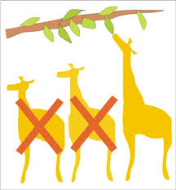
Natural Selection
(na-tu-ral se-lec-tion)
Communism
(com-mun-ism)
Impressionism
(im-pres-sion-ism)
Neo-classicism
(neo-clas-si-cism)
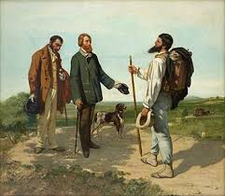
Realism
(re-al-ism)
Romanticism
(ro-man-ti-cism)
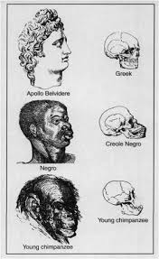
Social Darwinism
(so-cial dar-win-ism)
Socialism
(so-cial-ism)
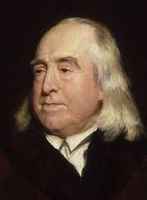
Utilitarianism
(u-ti-li-ta-ri-an-ism)
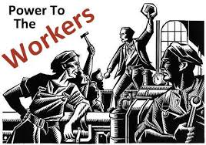
Proletariat
(pro-le-ta-ri-at)
Realpolitik
(re-al-po-li-tik)
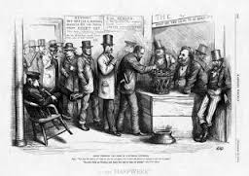
Universal Male Suffrage
(u-ni-ver-sal suf-frage)
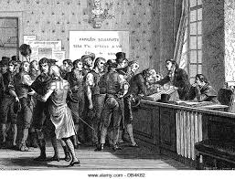
Plebiscite
(ple-bis-cite)
Entrepreneur
(en-tre-pre-ne-ur)
Capital
(ca-pi-tal)
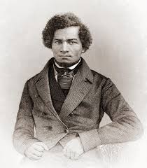
Abolitionism
(a-bo-li-tion-ism)
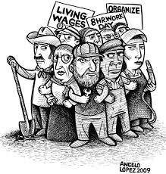
Union
(u-ni-on)

