Directions: The first thing you need to do is use a device and Google your term plus the word ‘definition’. Then, you will need to write a complete sentence that uses the word correctly! Enjoy your learning and this is due at the END OF THE TIMED PERIOD!
Vocabulary Term: | Definition: | Sentence Use:
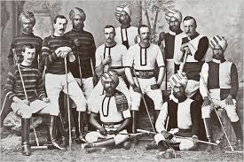
Imperialism
(im-pe-ri-al-ism)
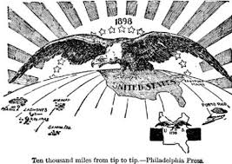
Protectorate
(pro-tec-to-rate)
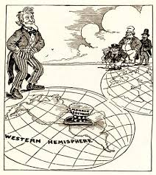
Spheres of Influence
(s-phe-re of in-flu-ence)
Assimilation
(as-si-mi-la-tion)
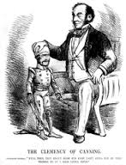
Paternalism
(pa-ter-nal-ism)
Commodity
(com-mo-di-ty)
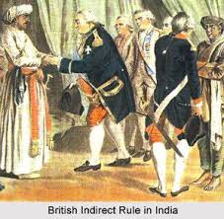
Indirect Rule
(in-di-rect rule)
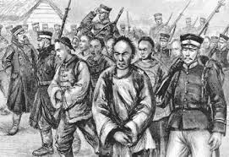
Direct Rule
(di-rect rule)
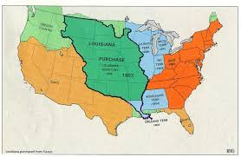
Annex
(an-nex)
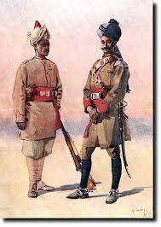
Sepoy
(se-poy)
Viceroy
(vice-roy)
Prefecture
(pre-fec-ture)
Extraterritoriality
(ex-tra-ter-ri-to-ri-al-i-ty)
Provincial
(pro-vin-cial)

