Directions: The first thing you need to do is use a device and Google your term plus the word ‘definition’. Then, you will need to write a complete sentence that uses the word correctly! Enjoy your learning and this is due at the END OF THE TIMED PERIOD!
Vocabulary Term: | Definition: | Sentence Use:
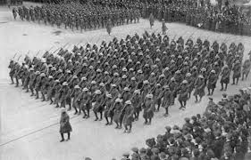
Militarism
(mi-li-tar-ism)
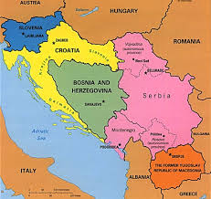
Balkanization
(bal-ka-ni-za-tion)
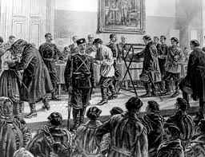
Conscription
(Con-scrip-tion)
Propaganda
(pro-pa-gan-da)
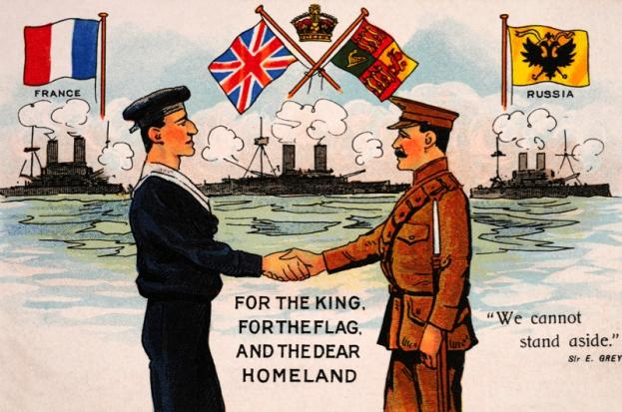
Alliance
(al-li-ance)
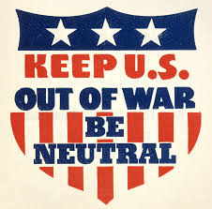
Isolationism
(i-so-la-tion-ism)
Neutrality
(neu-tra-li-ty)
Pan-Slavism
(pan-slav-ism)
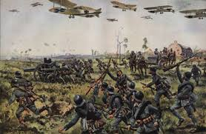
Total War
(to-tal war)
Totalitarianism
(to-ta-li-ta-ri-an-ism)
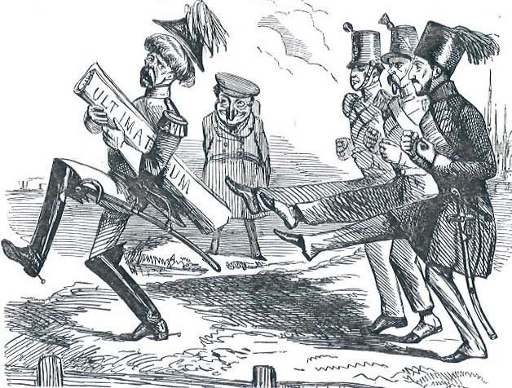
Ultimatum
(ul-ti-ma-tum)
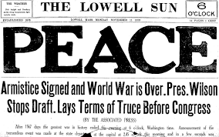
Armistice
(ar-mis-tice)
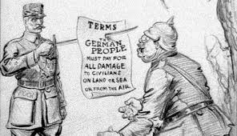
Reparations
(re-pa-ra-tions)
Abdicate
(ab-di-cate)

