Reading #1

Valentine’s Day Is Banned by the Religious Police in Saudi Arabia

Read the selection and choose the best answer to each question. Then fill in the answer on your answer document.

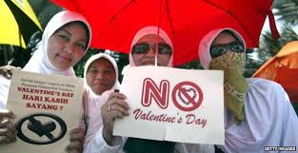

1 Red roses lurk hidden in flower shop back rooms and heart shaped chocolates are sold under the counter but still, Saudi’s manage to buy Valentine gifts and defy the Muttawa, or Religious Police. Florist Hussein came up with a simple solution to a ban on Red tokens of love. He filled his window with white roses, orange irises, and violet hydrangeas. I've hidden everything red in the shop, so when a religious police patrol comes along, they find nothing to complain about he said.

2 Anti-Valentine's day patrols by the religious police, formally known as the Commission for the Promotion of Virtue and Prevention of Vice started on Wednesday and continue until the day after Valentine’s day. They began entering premises that normally stock chocolate flowers and souvenirs to, warn proprietors again selling anything red or heart shaped and link to the annual infidel celebration of matters romantic.

3 Saudi Arabia applies a rigorous interpretation of Islam under which the sexes are strictly segregated and any public display of affection (PDA’s) are completely taboo. It is also the only country in the world where women are not allowed to drive. Hussein’s shop window may be blooming with white, orange, and violet, but he still has the real thing (red roses) hidden out back. I have sold at least 350 red roses at 20 Riyals ($6.00) each he said. Many women call us incognito on the phone to order roses because they fear the religious police and will not come to the store.

4 Kumar, another florist, was persuaded by a Muttawa visit to not even consider flouting the Valentine's day ban. Instead he insisted, “We're going to sell these to a chocolate shop”, pointing to the bouquets of red flowers in a back room of his store. Kumar needs the business, but cannot afford to have his shop connected to the illegal trade.

5 Confectioners do have chocolate hearts for discreet sale but only to the right people. “Of course we have them, but the Religious Police came by and warned us against selling them”, said one chocolate shop owner who asked not to be identified. “We hid them because we do not want any problems with the government”, he added- smiling and indicating that an illicit transaction involving the chocolate candy contraband would be more than acceptable to us right now.

It’s Only Chocolate!
6 In another shop in a commercial district of the capital, an Egyptian employee said the Religious Police had told them not to sell heart shaped chocolate or sweets wrapped in red paper. One man browsing in the shop was clearly unhappy. He asked, “Why are they for bidden; it's only chocolate!” Another customer, an older man, shot him a dark look and solemnly nodded his head in disgrace. Only a tiny liberal fringe of Saudis actually celebrates Valentine's Day, and when done, it is not in public. They do so in an ultraconservative society in which Clerics and their pronouncements are widely respected. One of Saudi’s most popular Twitter users, Mohammed al-Oreifi, decreed that those in the Kingdom who celebrate Valentine's Day want to copy the infidels.

7 However not everywhere is the band so strictly enforced. In the Red Sea port of Jeddah -the countries commercial capital to the west- a more liberal attitude towards the lover’s festival can be found. This year some florists have been openly selling red roses and are unafraid to verbally give their names (however they did ask us not print their names). “The Religious Police didn't come. We're doing nothing wrong anyway,” said Abu Zakaria who owns a flower shop in the North of the port city. Another man Thamer Hussein, said some people with romantic yearnings mark the Valentines festival a week in advance, to ensure the experience was hassle free. These younger people celebrate Saint Valentine's Day with small parties and exchanges of gifts. This way, they managed to avoid the attention of the Muttawa, who are expected to perform their duties religiously on Valentine's Day, ensuring that no couples sneak in extra love or public displays of affection (PDA’s).

Reading #2

Valentine’s Day 2017: What’s Love Got to Do with It? And who was St. Valentine?

Read the selection and choose the best answer to each question. Then fill in the answer on your answer document.
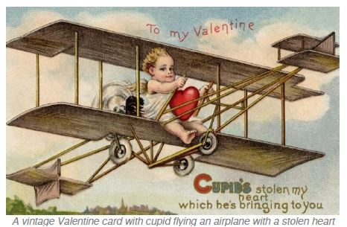

What day does Valentine's Day fall on this year?
St Valentine's Day, which falls on Tuesday February 14, is almost upon us. It's a day where people show their love and affection for another person - usually in the form of cards, flowers, gifts and messages.

But who was St Valentine?
The details are sketchy. Some say St Valentine was a priest from Rome who lived in the third century AD. Emperor Claudius II had banned marriages, believing married men made bad soldiers and St. Valentine is thought to have arranged marriages in secret.
He was imprisoned and sentenced to death for his crimes. There, St Valentine apparently fell in love with the jailer’s daughter and sent her a love letter signed ‘from your Valentine’ on February 14th, the day of his execution, as a goodbye.

When did Valentine's Day become so commercial?
It was during the middle of the 18th century that Valentine's started to take off in England, with lovers sending sweets and cards adorned with flowers, ribbons and images of cupids and birds.
Eventually huge numbers of printed cards replaced hand-written ones. In 1913, Hallmark Cards of Kansas City began mass producing Valentine's cards. Now about a billion Valentine's Day cards are exchanged and it has become the second largest seasonal card sending time of the year, second only to Christmas.
Florists are also extremely busy on February 14. More than 50 million roses are given for Valentine's Day every year. There will of course be some people who do not receive any cards, flowers or gifts on Valentine's Day. One teenager solved that problem by buying 900 carnations and giving them to out to all the girls at his school.

