DIRECTIONS: Use Google to identify the important details, achievements, and annotations about each historical figure from World War I listed below. Remember- avoid using Wikipedia!

Historical Figure | Annotations
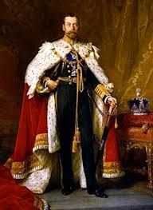  George V  Nationality: __________________ | Time Period: ______________________________________  Achievements: ____________________________________________________________________________ ______________________________________________________________________________________________ ______________________________________________________________________________________________ ______________________________________________________________________________________________  Notes: ______________________________________________________________________________________  ______________________________________________________________________________________________  ______________________________________________________________________________________________
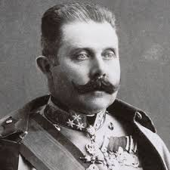  Archduke Franz Ferdinand  Nationality: _________________ | Time Period: ______________________________________  Achievements: ____________________________________________________________________________ ______________________________________________________________________________________________ ______________________________________________________________________________________________ ______________________________________________________________________________________________  Notes: ______________________________________________________________________________________  ______________________________________________________________________________________________  ______________________________________________________________________________________________
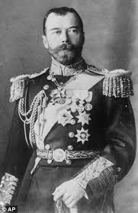  Czar Nicholas II  Nationality: ________________ | Time Period: ______________________________________  Achievements: ____________________________________________________________________________ ______________________________________________________________________________________________ ______________________________________________________________________________________________ ______________________________________________________________________________________________  Notes: ______________________________________________________________________________________  ______________________________________________________________________________________________  ______________________________________________________________________________________________
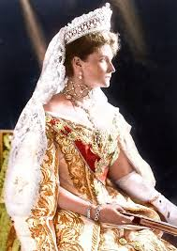  Alexandra Feodorovna  Nationality: ________________ | Time Period: ______________________________________  Achievements: ____________________________________________________________________________ ______________________________________________________________________________________________ ______________________________________________________________________________________________ ______________________________________________________________________________________________  Notes: ______________________________________________________________________________________  ______________________________________________________________________________________________  ______________________________________________________________________________________________
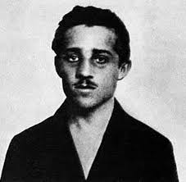  Gavrilo Princip  Nationality: ________________ | Time Period: ______________________________________  Achievements: ____________________________________________________________________________ ______________________________________________________________________________________________ ______________________________________________________________________________________________ ______________________________________________________________________________________________  Notes: ______________________________________________________________________________________  ______________________________________________________________________________________________  ______________________________________________________________________________________________
Black Hand  Nationality: ________________ | Time Period: ______________________________________  Achievements: ____________________________________________________________________________ ______________________________________________________________________________________________ ______________________________________________________________________________________________ ______________________________________________________________________________________________  Notes: ______________________________________________________________________________________  ______________________________________________________________________________________________  ______________________________________________________________________________________________
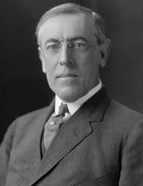  Woodrow Wilson  Nationality: ________________ | Time Period: ______________________________________  Achievements: ____________________________________________________________________________ ______________________________________________________________________________________________ ______________________________________________________________________________________________ ______________________________________________________________________________________________  Notes: ______________________________________________________________________________________  ______________________________________________________________________________________________  ______________________________________________________________________________________________
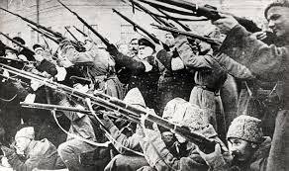  Bolsheviks  Nationality: ________________ | Time Period: ______________________________________  Achievements: ____________________________________________________________________________ ______________________________________________________________________________________________ ______________________________________________________________________________________________ ______________________________________________________________________________________________  Notes: ______________________________________________________________________________________  ______________________________________________________________________________________________  ______________________________________________________________________________________________
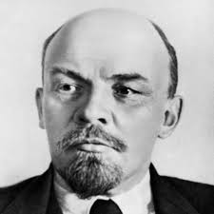  Vladimir Lenin  Nationality: ________________ | Time Period: ______________________________________  Achievements: ____________________________________________________________________________ ______________________________________________________________________________________________ ______________________________________________________________________________________________ ______________________________________________________________________________________________  Notes: ______________________________________________________________________________________  ______________________________________________________________________________________________  ______________________________________________________________________________________________
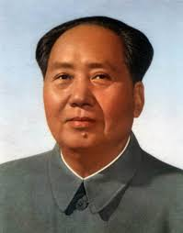  Mao Zedong  Nationality: ________________ | Time Period: ______________________________________  Achievements: ____________________________________________________________________________ ______________________________________________________________________________________________ ______________________________________________________________________________________________ ______________________________________________________________________________________________  Notes: ______________________________________________________________________________________  ______________________________________________________________________________________________  ______________________________________________________________________________________________
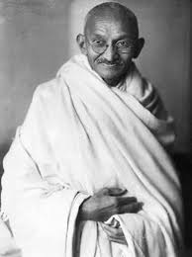  Mohandas K. Gandhi  Nationality: ________________ | Time Period: ______________________________________  Achievements: ____________________________________________________________________________ ______________________________________________________________________________________________ ______________________________________________________________________________________________ ______________________________________________________________________________________________  Notes: ______________________________________________________________________________________  ______________________________________________________________________________________________  ______________________________________________________________________________________________
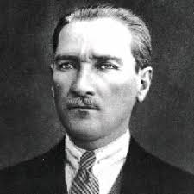  Mustafa Kemal  Nationality: ________________ | Time Period: ______________________________________  Achievements: ____________________________________________________________________________ ______________________________________________________________________________________________ ______________________________________________________________________________________________ ______________________________________________________________________________________________  Notes: ______________________________________________________________________________________  ______________________________________________________________________________________________  ______________________________________________________________________________________________
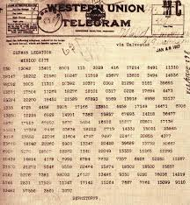  Zimmermann Telegram  Nationality: ________________ | Time Period: ______________________________________  Achievements: ____________________________________________________________________________ ______________________________________________________________________________________________ ______________________________________________________________________________________________ ______________________________________________________________________________________________  Notes: ______________________________________________________________________________________  ______________________________________________________________________________________________  ______________________________________________________________________________________________
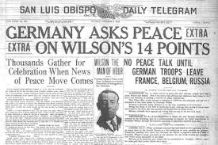  Fourteen Points  Nationality: ________________ | Time Period: ______________________________________  Achievements: ____________________________________________________________________________ ______________________________________________________________________________________________ ______________________________________________________________________________________________ ______________________________________________________________________________________________  Notes: ______________________________________________________________________________________  ______________________________________________________________________________________________  ______________________________________________________________________________________________
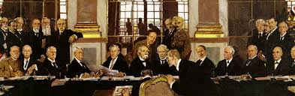  Treaty of Versailles  Nationality: ________________ | Time Period: ______________________________________  Achievements: ____________________________________________________________________________ ______________________________________________________________________________________________ ______________________________________________________________________________________________ ______________________________________________________________________________________________  Notes: ______________________________________________________________________________________  ______________________________________________________________________________________________  ______________________________________________________________________________________________
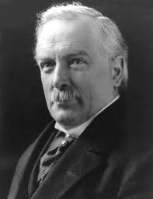  David Lloyd George  Nationality: ________________ | Time Period: ______________________________________  Achievements: ____________________________________________________________________________ ______________________________________________________________________________________________ ______________________________________________________________________________________________ ______________________________________________________________________________________________  Notes: ______________________________________________________________________________________  ______________________________________________________________________________________________  ______________________________________________________________________________________________
League of Nations | Time Period: ______________________________________  Achievements: ____________________________________________________________________________ ______________________________________________________________________________________________ ______________________________________________________________________________________________ ______________________________________________________________________________________________  Notes: ______________________________________________________________________________________  ______________________________________________________________________________________________  ______________________________________________________________________________________________

